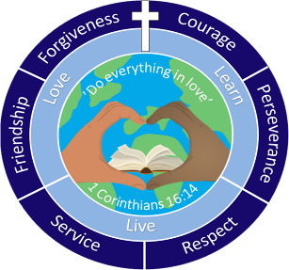

Together We Love, Live and Learn
December Newsletter 2024

The value of this term is Forgiveness.

We will talk with the children about how it takes a strong person to say sorry, and an even stronger person to forgive. We will explain that when you forgive, you don’t change the past but the future.
‘Just as the Lord has forgiven you, so you must also forgive others.’ Colossians 3.1
Happy December: I always find it one of the busiest and most exciting months in school, as we count down to Christmas with excitement.
I wanted to take this opportunity to introduce myself to those of you that don’t know me. 
I’m Jen Panton, the SENDCo here at Hardwicke. My role is to ensure that children with special educational needs and disabilities (SEND) within our school receive the support they need to successfully access a creative and engaging curriculum.
Alongside overseeing the day-to-day operation of the school’s SEND policy, my other duties include:
- Supporting the identification of children with SEND.
- Working with all staff to plan exciting and effective provision for learners.
- Co-ordinating and assessing provision for children with SEND to ensure maximum impact.
- Liaising with parents/carers of children with SEND.
- Liaising with other providers, outside agencies, educational psychologists, behaviour support services and other external agencies.
- Ensuring that the school keeps accurate and up to date records for all pupils with SEND.
I’d like to let you know that my door is always open. If you have any worries, big or small, please come and see me as I run past or make an appointment for a longer chat.

Dates for December
2nd December | Beech House: Non-Uniform Day  Last week of teacher-led clubs
6th December | Wreath Making: HPSA
9th December | Last week of Atlas Clubs
11th December | Christmas Dinner  Children can wear Christmas Jumpers
12th December | Non-Uniform Day in exchange for Hamper Prize  School Disco
12th December | EYFS Nativity at 2 pm
13th December | Wrap Around Christmas Party
17th December | Year 3 Christmas: 9:15 am
19th December | St. Nicholas Church Service at 7:30 pm
20th December | Last Day of Term: Finish at 1:10 pm  No Wrap around care after school.
6th January | Return to school for Spring Term 1

