**Inspiring Children to** **Shine**

**‘Walk as children of light’**

**Hardwicke Parochial Primary School: Newsletter 16**

The school value of this term is **Thankfulness.**

**‘Always be thankful.’ 1 Thessalonians 5.16**

The Summer Term continues to be a busy one.

**Year 6 SAT’s**

I would like to start by congratulating the year 6 children for all their positive attitudes towards their SATs. They all came into school ready to complete their tests and achieve their best. I also would like to thank the year 6 staff and all those who supported them during the week. I do know that the children really enjoyed the sausage baps in the morning too!

**Year 6 Residential**

After SATs week, Year 6 went on a residential trip to TRAC led by Tim and his Sportily team. We had an amazing three days and the children were very well-behaved. We took part in various activities such as climbing, caving, boating, and riding go-carts. There was only one trip to the A&E, and that was for the party leader, Miss Cook, who managed to break her fingers while playing with the children. We are thankful to Miss Cook for her leadership and organisation; a lot of hard work has gone into making this happen. Booking with Sportily helped us keep the costs well below the average price, so we are looking at something very similar next year.

Hopefully, we posted enough pictures for you to enjoy sharing in the great time the children and adults were having.

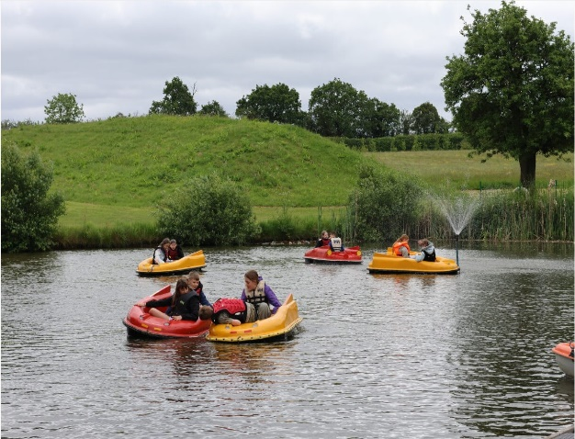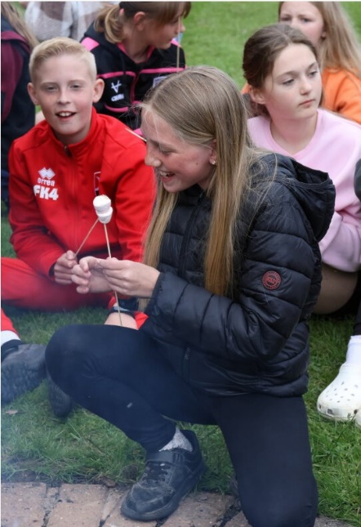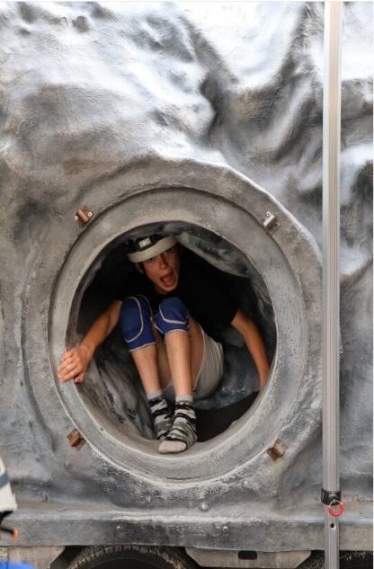

**Deputy Head Appointment and Staff Changes**

We are excited to announce that Mr Allard will be joining us as the new Deputy Head starting in September. Mr Allard impressed us all during the interview process, standing out amongst a very competitive pool of candidates. Currently, he is a phase leader at a school in Cheltenham. He received positive feedback from the interview panel, staff, and even the children who interviewed him. Mrs Walpole, who organised the pupil interviews, was particularly impressed with the pupils' questions and the overall outcomes of their decisions. Mr Allard will appeal to our mathematicians and sporty girls and boys as he plays a high standard of golf and has played at a high standard in football across the county. In addition, he has led the Mastery Maths programme across his current school which has led to positive results for the learners at his school.

Sadly, Mrs Duffy is leaving the Hardwicke team. She will be joining Kingsholm Primary School in September. We wish her all the best in her new journey and we would like to thank her for the service that she has given to Hardwicke.

We have recently appointed a male and female teacher to replace the two members of staff that are retiring, Mrs Walpole and Mrs Arinze. We have decided to employ two experienced teachers as we know this will be a tough act to follow after their loyal service of over 20 years. These teachers will be in school before the end of the term so they can meet the children in their classes. We will announce who they are as soon as their school community are informed.

**Sports Day**

Sports day is on Thursday 13th June. We are trialling something new so please bear with us on the day if there are any issues.

**KS1 parents** are invited to watch their children’s track events in the morning from 9:30 – 11 am.

**KS2 parents** are invited to watch their children’s track events from 1:15 – 2:30 pm.

Parents will need to enter via the office, where you will be asked to sign in. There will be designated ‘Parent Zones’ for you to spectate from. Due to safeguarding, it is important that you remain in your areas for the duration of the event.

Sports Day is a fantastic, fun day where all children get the opportunity to compete in teams in a range of sporting events, which provides lots of opportunities to celebrate individual and team successes. We look forward to many of you joining us on the day, and will keep our fingers crossed for nice weather! In the event that we cannot go ahead due to weather, we will let you know by 8 – 8:30 am and we will provide a rescheduled date as soon as possible.

**Christian Values and Community Spirit**

Mr and Mrs Thomas continue to improve the area outside the hall giving up their own time which is so exciting. Thank you very much for your support.

Also thank you to Mrs Evans and her team for clearing the Forest School area, now that we are finally allowed back into the site after its flooding.

**If any of our community would like to support these projects, please discuss it with the office staff. Many hands make light work!**

**Year 1**

Violin lessons continuing this term.

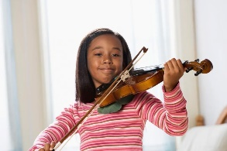

**Slimbridge Wildlife Park**

Year 5 visited Slimbridge Wildfowl Trust as part of their Science topic. The children enjoyed their day out and the activities provided by the centre. They enjoyed spotting the different types of birds and listening to the otter talk. They also came up with some amazing questions to ask the staff about Sir Peter Scott when they were given a tour of his house. Staff at Slimbridge commented on the respect both classes showed when listening to the talks.

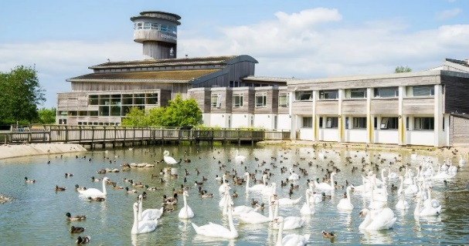

**HSPA**

Thank you to those who supported Quiz Night. It was fantastic to see lots of members of staff supporting the HSPA as well as families. Even though I didn’t get in the top five, I still enjoyed the evening. Thank you!

**School Holiday Dates 2024-2025**

Just a reminder, a letter was sent out and these dates have been placed on the school website.

<http://www.hardwicke.gloucs.sch.uk/web/term_dates/638034>

We finish school **this** academic term on Monday **22nd July** at **1:10 pm**.

**Message from the Community**

On Sunday, June 9th we are celebrating Youth with a Street Parade from Severn Vale School to St.James’ Church starting at 12:45 pm. There is a market on School Lane near the church as well as some demos both in the Community Centre and the Club Car Park. There is also a Church Service starting at 1.30 pm during which a new Royal British Legion Standard will be dedicated and we will remember Sergeant John Smith who was killed just a few days after the start of WW1. Everyone is welcome to either or both.



**Shine Awards**

|  |  |  |  |  |  |  |  |
| --- | --- | --- | --- | --- | --- | --- | --- |
|  | Week 1 | Week 2 | Week 3 | Week 4 | Week 5 | Week 6 | Week 7 |
| REC | Arthur L |  |  |  |  |  |  |
| Year 1 | 1Da – David O  1Du – Mohammed H |  |  |  |  |  |  |
| Year 2 | 2B – Olivia  2S - Elliott |  |  |  |  |  |  |
| Year 3 | 3H – George L  3W – Saskia P |  |  |  |  |  |  |
| Year 4 | 4P – Theo W  4W – Darcie B |  |  |  |  |  |  |
| Year 5 | 5H – Phoebe R  5S – Mohammad H  Setaish B |  |  |  |  |  |  |
| Year 6 | 6C – Emma S  6F – Jacob W |  |  |  |  |  |  |

**Summer Term 2**

|  |  |
| --- | --- |
| **Date** | **Event** |
| **7th June** | All Things Wild: EYFS |
| **11th June** | Cotswold Wildlife Park: Year 4  Maidenhill visit for transition Year 6 |
| **13th June** | Sports Day  am (KS 1 Parents)  pm (Key Stage 2 Parents) |
| **17th June** | Bikeability |
| **17th June** | Swimming: Year 3  All Week (am) Mon - Thurs |
| **20th June** | EYFS: Story Session and Coffee Evening  School beat Officer visit: Year 6 |
| **21st June** | Summer Fayre from 3.30 pm |
| **24th June** | Swimming: Year 3  All Week (am) Mon - Thurs |
| **2nd July** | Robinswood Hill Trip: Year 3 |
| **4th July** | New EYFS: Stay and Play |
| **10th July** | Year 6 Show |
| **11th July** | Year 6 Show |
| **11th July** | Robinswood Hill Trip: Year 3 |
| **15th July** | School Reports sent to parents |
| **18th July** | Mrs Walpole and Mrs Arinze Leaving Celebration |
| **19th July** | Hot Chocolate Friday |
| **8th July** | Week of Year 6 Production: Final dates TBC |
| **11th July** | Robinswood Hill Trip Year 3 |  |
| **22nd July** | Year 6 Leavers Assembly 9:30 am  Finish School at 1:10 pm |  |

**If you have any questions, please do not hesitate to catch me in the playground or by email at** [head@hardwicke.gloucs.sch.uk](mailto:head@hardwicke.gloucs.sch.uk)